**Industrial Internship Report on**

**”Banking Information System”**

**Prepared by**

**Lakshay Rajput**

|  |
| --- |
| *Executive Summary* |
| This report provides details of the Industrial Internship provided by upskill Campus and The IoT Academy in collaboration with Industrial Partner UniConverge Technologies Pvt Ltd (UCT).  This internship was focused on a project/problem statement provided by UCT. We had to finish the project including the report in 6 weeks’ time.  My project was (Tell about ur Project)  This internship gave me a very good opportunity to get exposure to Industrial problems and design/implement solution for that. It was an overall great experience to have this internship. |

**TABLE OF CONTENTS**

1 Preface 3

2 Introduction 4

2.1 About UniConverge Technologies Pvt Ltd 4

2.2 About upskill Campus 8

2.3 Objective 9

3 Problem Statement 11

4 Existing and Proposed solution 12

5 Proposed Design/ Model 13

5.1 High Level Diagram (if applicable) 13

5.2 Low Level Diagram (if applicable) 13

5.3 Interfaces (if applicable) 13

6 Performance Test 14

6.1 Test Plan/ Test Cases 14

6.2 Test Procedure 14

6.3 Performance Outcome 14

7 My learnings 15

8 Future work scope 16

# Preface

Summary of the whole 6 weeks’ work

During my internship, I had the valuable opportunity to enhance my skills and knowledge in the field of software development. The internship spanned over a period of five weeks and encompassed various learning and practical experiences.

In the initial week, I familiarized myself with the operations of Upskill Campus, the host organization. This involved gaining insights into the organization's functioning and identifying challenges it faced. As a part of this, I also designed and administered a quiz focusing on Upskill Campus Technologies (UCT) to assess the level of understanding among fellow interns.

The second week marked the commencement of my technical learning journey. After gaining a foundational understanding of Java concepts through the resources provided by Upskill Campus, I developed Quiz 1 centered around core Java principles. This exercise allowed me to solidify my understanding while also serving as an evaluative tool for my peers.

Progressing into the third week, I began actively participating in a project. Simultaneously, I continued my learning journey with Upskill Campus, receiving comprehensive content about Java programming. This phase was crucial as it enabled me to apply theoretical knowledge to a practical project, enhancing my problem-solving and coding skills.

The fourth week saw the continuation of my project work alongside advanced Java concepts from Upskill Campus. To evaluate my own growth and understanding, I designed and administered Quiz 2, focusing on more intricate Java concepts. This iterative learning process helped me grasp complex topics and apply them effectively.

Entering the fifth week, I conducted another knowledge assessment through a quiz. By this point, my project, which revolved around the creation of a Banking Information System, had reached completion. This involved implementing various software engineering principles and applying Java programming techniques to develop a functional system.

In conclusion, my internship provided a holistic learning experience that combined theoretical knowledge from Upskill Campus with practical project work. The quizzes I designed and administered not only assessed my understanding but also fostered my growth as a programmer. The successful completion of the Banking Information System project stands as a testament to my improved skills and the enriching experience I gained during the internship.

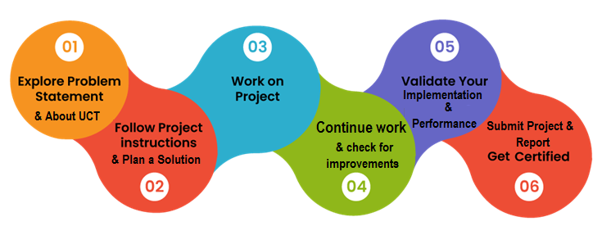

Need of relevant Internship in career development

A relevant internship is a vital asset for career development, offering practical application of knowledge, skill enhancement, and industry insights. It builds real-world competencies, expands networks, and boosts confidence. Internships illuminate career paths, enhance resumes, and provide a firsthand understanding of workplace dynamics. In today's competitive job market, they are a crucial investment in shaping a successful and fulfilling professional future.

Problem Statement: Banking Information System

Develop a prototype of aBanking Information Systemin Core Java that provides a working preview of the key functionalities of a real banking system. The prototype should demonstrate the core features and flow of the system, showcasing its functionality and usability.

Opportunity given by USC/UCT

How Program was planned

Your Learnings and overall experience.

Thank to all (with names), who have helped you directly or indirectly.

Your message to your juniors and peers.

# Introduction

## About UniConverge Technologies Pvt Ltd

A company established in 2013 and working in Digital Transformation domain and providing Industrial solutions with prime focus on sustainability and RoI.

For developing its products and solutions it is leveraging various**Cutting Edge Technologies e.g. Internet of Things (IoT), Cyber Security, Cloud computing (AWS, Azure), Machine Learning, Communication Technologies (4G/5G/LoRaWAN), Java Full Stack, Python, Front end**etc.

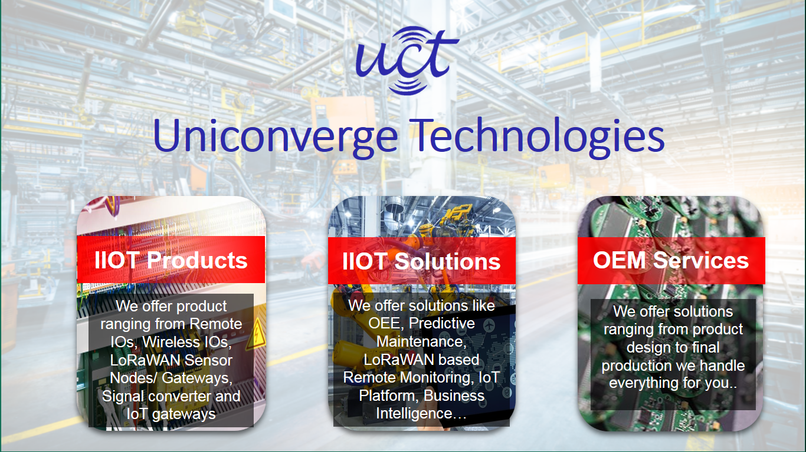

1. UCT IoT Platform **(****)**

**UCT Insight** is an IOT platform designed for quick deployment of IOT applications on the same time providing valuable “insight” for your process/business. It has been built in Java for backend and ReactJS for Front end. It has support for MySQL and various NoSql Databases.

* It enables device connectivity via industry standard IoT protocols - MQTT, CoAP, HTTP, Modbus TCP, OPC UA
* It supports both cloud and on-premises deployments.

It has features to  
• Build Your own dashboard  
• Analytics and Reporting  
• Alert and Notification  
• Integration with third party application(Power BI, SAP, ERP)  
• Rule Engine

 

1. **Smart Factory Platform (****)**

Factory watch is a platform for smart factory needs.

It provides Users/ Factory

* with a scalable solution for their Production and asset monitoring
* OEE and predictive maintenance solution scaling up to digital twin for your assets.
* to unleased the true potential of the data that their machines are generating and helps to identify the KPIs and also improve them.
* A modular architecture that allows users to choose the service that they what to start and then can scale to more complex solutions as per their demands.

Its unique SaaS model helps users to save time, cost and money.



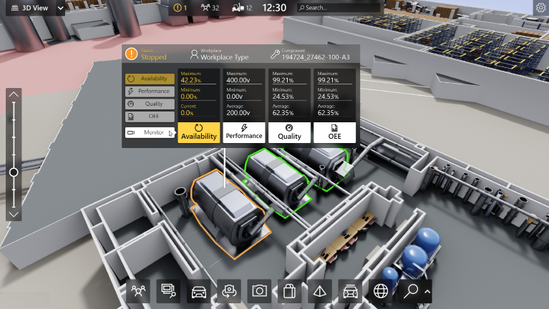



based Solution

UCT is one of the early adopters of LoRAWAN teschnology and providing solution in Agritech, Smart cities, Industrial Monitoring, Smart Street Light, Smart Water/ Gas/ Electricity metering solutions etc.

1. Predictive Maintenance

UCT is providing Industrial Machine health monitoring and Predictive maintenance solution leveraging Embedded system, Industrial IoT and Machine Learning Technologies by finding Remaining useful life time of various Machines used in production process.



## About upskill Campus (USC)

upskill Campus along with The IoT Academy and in association with Uniconverge technologies has facilitated the smooth execution of the complete internship process.

USC is a career development platform that delivers **personalized executive coaching** in a more affordable, scalable and measurable way







Seeing need of upskilling in self paced manner along-with additional support services e.g. Internship, projects, interaction with Industry experts, Career growth Services

upSkill Campus aiming to upskill 1 million learners in next 5 year

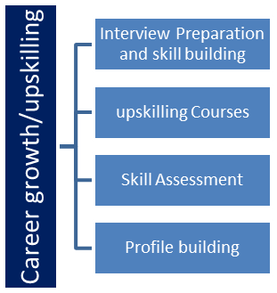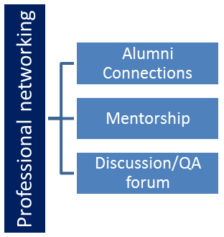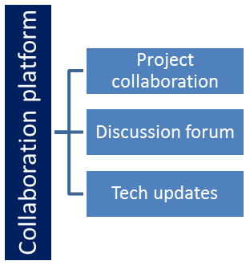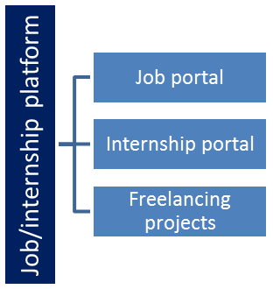

<https://www.upskillcampus.com/>

## The IoT Academy

The IoT academy is EdTech Division of UCT that is running long executive certification programs in collaboration with EICT Academy, IITK, IITR and IITG in multiple domains.

## Objectives of this Internship program

The objective for this internship program was to

 ☛ get practical experience of working in the industry.

 ☛ to solve real world problems.

 ☛ to have improved job prospects.

 ☛ to have Improved understanding of our field and its applications.

 ☛ to have Personal growth like better communication and problem solving.

# Problem Statement

**Develop a prototype of a Banking Information System in Core Java that provides a working preview of the key functionalities of a real banking system. The prototype should demonstrate the core features and flow of the system, showcasing its functionality and usability.**

Key Functionality to Include in the Prototype:

1. User Registration: Implement a simplified user registration process where users can provide basic details to create an account.
2. Account Management: Develop the ability to create and manage user accounts, including assigning unique account numbers and tracking account balances.
3. Deposit and Withdrawal: Enable users to make deposits and withdrawals from their accounts, updating the account balance accordingly.
4. Fund Transfer: Implement a simplified version of fund transfer functionality, allowing users to transfer funds between their accounts or to other registered users.
5. Account Statements: Provide users with a preview of their account statements, displaying transaction history, dates, amounts, and remaining balances.
6. Password Protection: Develop a basic login system with password authentication to ensure secure access to user accounts.
7. Error Handling: Implement basic error handling mechanisms to handle common exceptions, such as insufficient funds and invalid transactions, and display relevant error messages to users.
8. User Interface: Design a user-friendly interface for the prototype that allows users to navigate through the system, perform banking operations, and view relevant information.
9. Persistence: Implement basic data persistence by storing user account information and transaction history temporarily during the prototype session.

By developing this prototype, stakeholders will have a tangible working preview of the key features and functionality of the Banking Information System. This will allow them to evaluate the system's usability, identify any necessary improvements or enhancements, and make informed decisions for further development and deployment of the complete system.

Minimum Requirements and System Output

1. User Registration:

* Form Creation: Create a user registration form that prompts users to input their personal details, such as name, address, contact information, and initial deposit amount.
* Output: Upon successful registration, the system will generate a unique account number for the user, and the user's details will be stored in the system's memory or File System.

The output will be a confirmation message indicating successful registration.

2. Account Management:

* Form Creation: Develop an account management form that allows users to view and update their account information, such as name, address, contact details, and account settings.
* Output: After making any updates or changes, the system will display a confirmation message indicating that the account information has been successfully updated.

3. Deposit and Withdrawal:

* Form Creation: Design a form where users can enter the amount they wish to deposit or withdraw from their account.
* Output: Upon successful deposit or withdrawal transaction completion, the system will update the account balance accordingly and display a confirmation message indicating the transaction details, such as the transaction amount and the resulting balance.

4. Fund Transfer:

* Form Creation: Create a form that allows users to specify the recipient's account number and the amount they wish to transfer.
* Output: After a successful fund transfer, the system will deduct the transferred amount from the sender's account, add it to the recipient's account, and display a confirmation message indicating the transaction details, including the transferred amount and the updated balances of both accounts.

5. Account Statements:

Output: Implement a feature that allows users to view their account statements, which will be displayed as a comprehensive list showing transaction history, including dates, transaction amounts, and resulting balances. Users can access their account statements through a designated section of the system's user interface.

# 

# Proposed solution

The Banking Information System project I developed using Java, Java Swing, and MySQL is a comprehensive application designed to manage various aspects of banking operations in a user-friendly and efficient manner.

Java and Java Swing:

Java serves as the core programming language for this project, providing the foundation for the application's logic and functionality. Java's object-oriented nature facilitates modular design, making it easier to create, modify, and maintain the different components of the system. Java Swing, a graphical user interface (GUI) toolkit, is used to create the visual elements of the application. It ensures a responsive and interactive user experience by enabling the creation of windows, buttons, forms, and other graphical components.

MySQL Database:

MySQL is employed as the backend database management system to store and manage the banking-related data. It offers a reliable and efficient way to organize customer information, transaction records, account details, and other relevant data. The structured nature of a relational database like MySQL allows for seamless retrieval, storage, and manipulation of data.

Screenshots:



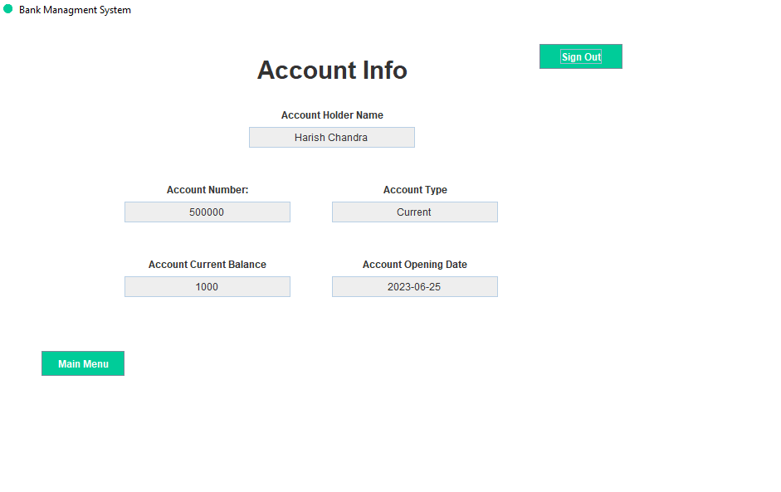

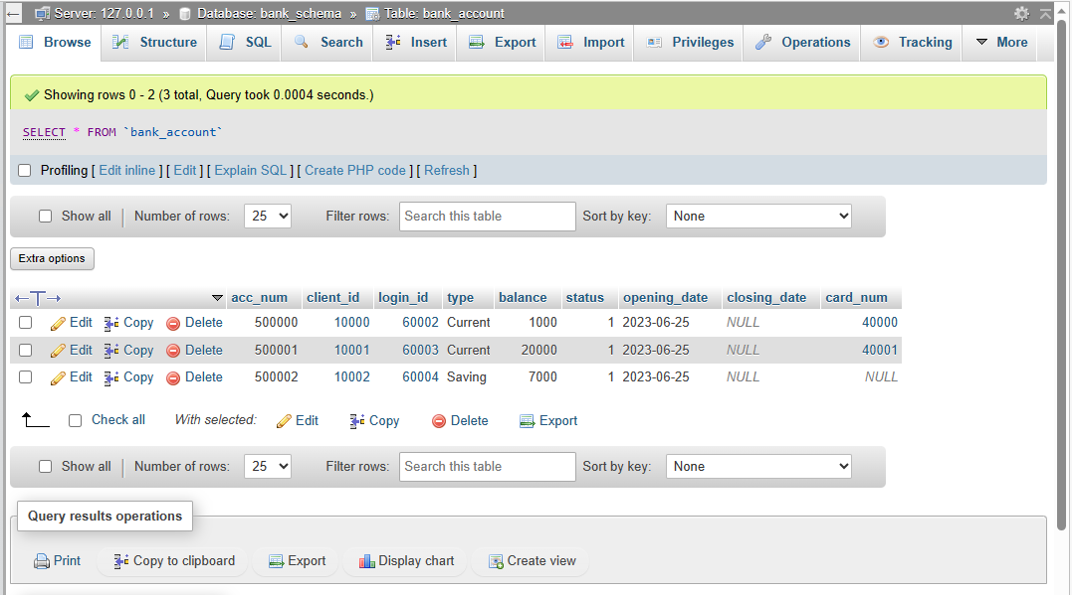

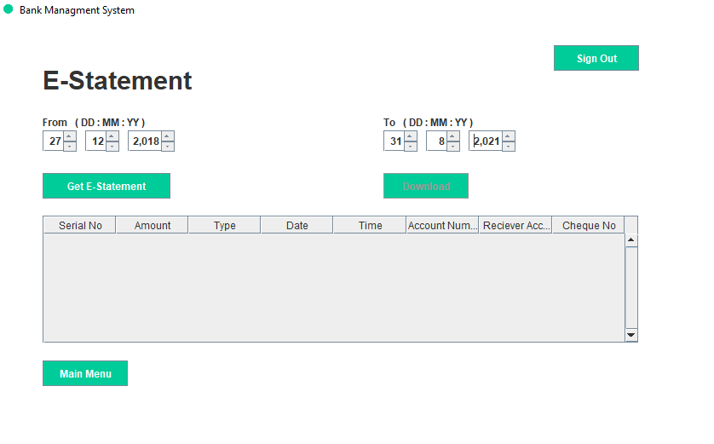

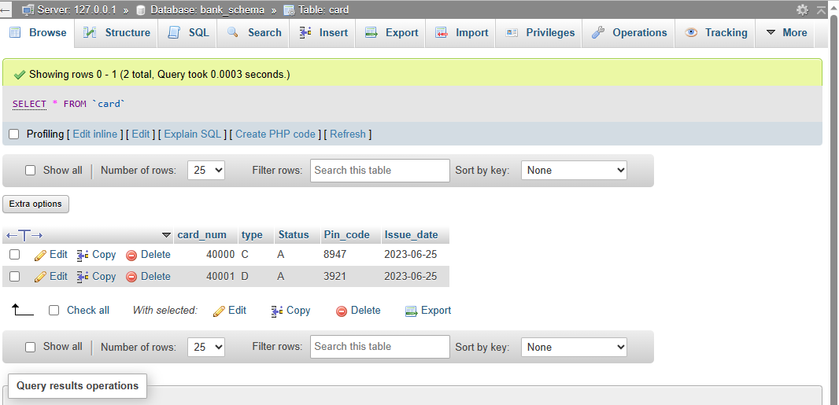

## Code submission (Github link: <https://github.com/lakshay-rajput4/upskillcampus.git>)

## Report submission (Github link: <https://github.com/lakshay-rajput4/upskillcampus.git>)

## Performance Test

This is very important part and defines why this work is meant of Real industries, instead of being just academic project.

Here we need to first find the constraints.

How those constraints were taken care in your design?

What were test results around those constraints?

Constraints can be e.g. memory, MIPS (speed, operations per second), accuracy, durability, power consumption etc.

In case you could not test them, but still you should mention how identified constraints can impact your design, and what are recommendations to handle them.

# My learnings

Developing the Banking Information System prototype in Core Java was a profound learning experience. I gained proficiency in Java programming, GUI development using Java Swing, and MySQL database management. Error handling, user-centric design, and project management skills were honed as I navigated through user registration, account management, and transaction processing. This project reinforced my grasp of object-oriented principles and the importance of systematic problem-solving. It also deepened my understanding of real-world software development, fostering skills in collaboration, critical thinking, and efficient time allocation. Overall, this project provided a tangible platform to apply theoretical knowledge to practical scenarios, equipping me with a comprehensive skill set for future endeavors.

**Future Work Scope**

While the current prototype successfully demonstrates the core functionalities of the Banking Information System, there are several avenues for further enhancement and expansion that could be explored in future development phases:

Enhanced Security Features: Implement more robust security measures, including encryption techniques and multi-factor authentication, to ensure the safety of user data and transactions.

Real-Time Updates: Integrate real-time updates for account balances and transaction history, providing users with immediate access to their current financial status.

Advanced Fund Transfer Options: Develop more advanced fund transfer mechanisms, such as scheduling recurring transfers, setting transaction limits, and enabling cross-bank transfers.

Data Analytics and Reporting: Introduce data analytics tools to generate insights from transaction data, enabling users to track spending patterns and make informed financial decisions.

Multi-Language Support: Incorporate multi-language support to accommodate users from diverse linguistic backgrounds and extend the system's accessibility.

Mobile Application: Create a mobile app version of the system to cater to users who prefer to perform banking operations on their smartphones, ensuring a seamless and convenient experience.

Notification System: Implement a notification system that alerts users about important account activities, such as deposits, withdrawals, and upcoming payments.

Integrate Payment Gateways: Enable integration with external payment gateways to facilitate online payments, bill payments, and e-commerce transactions directly through the banking system.

Automated Customer Support: Develop a chatbot or AI-based customer support system to address common user queries and provide assistance outside of regular banking hours.

Accessibility Compliance: Ensure compliance with accessibility standards (e.g., WCAG) to make the system usable by individuals with disabilities, enhancing inclusivity.

Scalability: Design the system architecture to handle a larger user base and increasing transaction volumes as the banking system expands.

Audit Trail: Implement an audit trail system to maintain a comprehensive record of all user interactions and system activities for security and compliance purposes.

Integration with External Services: Explore opportunities to integrate the system with third-party financial services, such as investment platforms or loan management systems.

Incorporating these enhancements and exploring these areas for future development can transform the prototype into a robust and comprehensive Banking Information System that offers advanced features, improved user experiences, and a broader range of services for both customers and the bank's operations.